***Components :***

-Stepper motor (28BYJ-48)

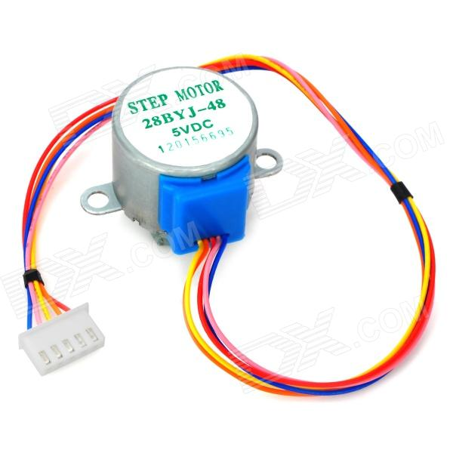

-unl 2003

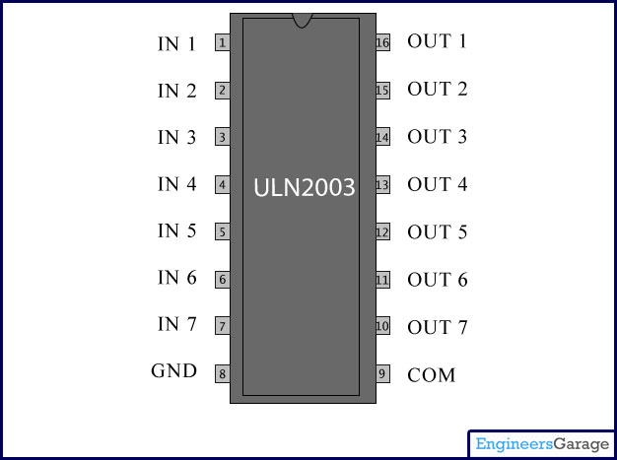

- common cathode 7 –segment

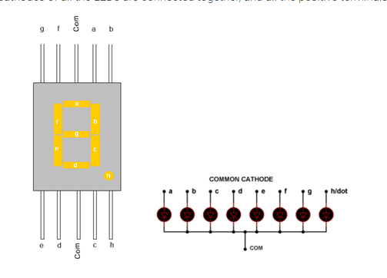

- C8051F020 Silicon labs Kit

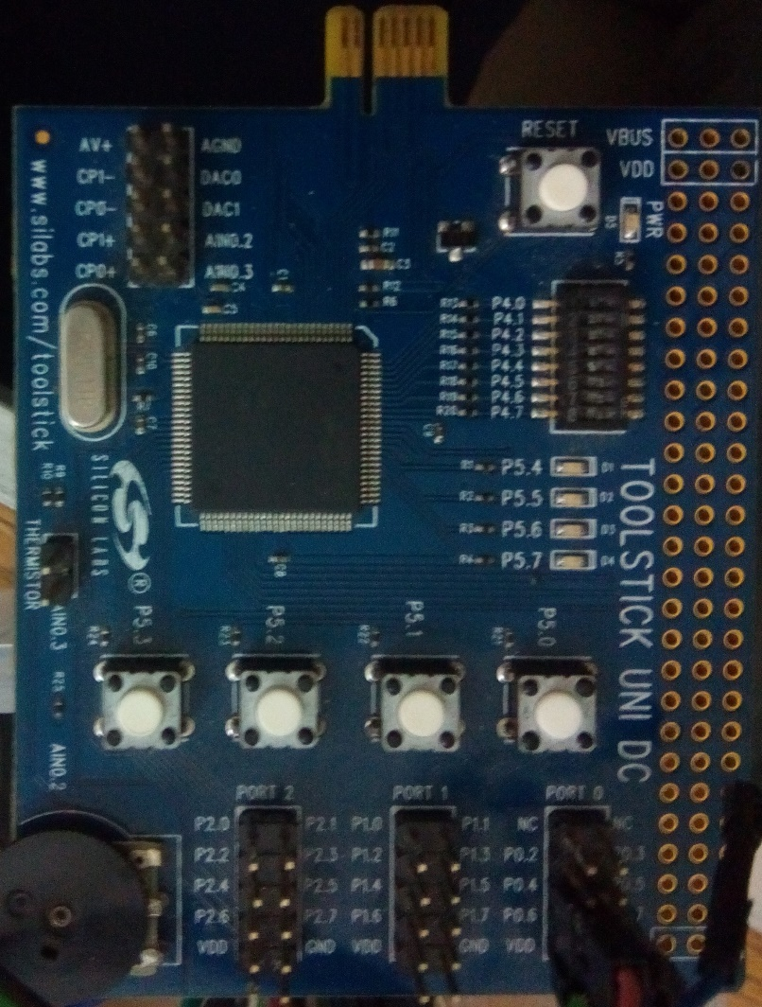

-Jumpers

- Breadboard

**Block Diagram :**

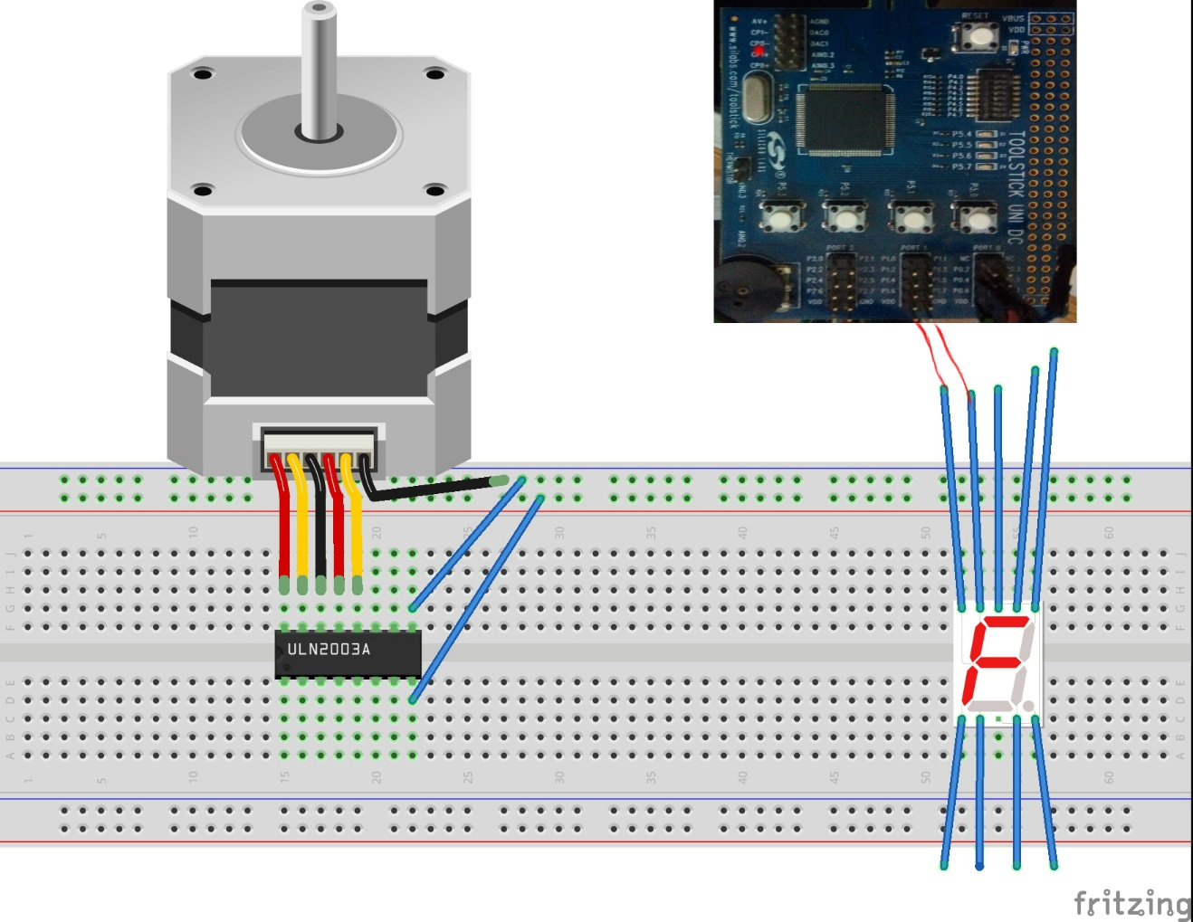

This is a simple block diagram I made it using some application

As shown I we should attach the input of the unl 2003 to the Pins of Ports 0 and the 7 –segment to the Pins of Port 3 as we did in our project

---------------------------------------------------------------

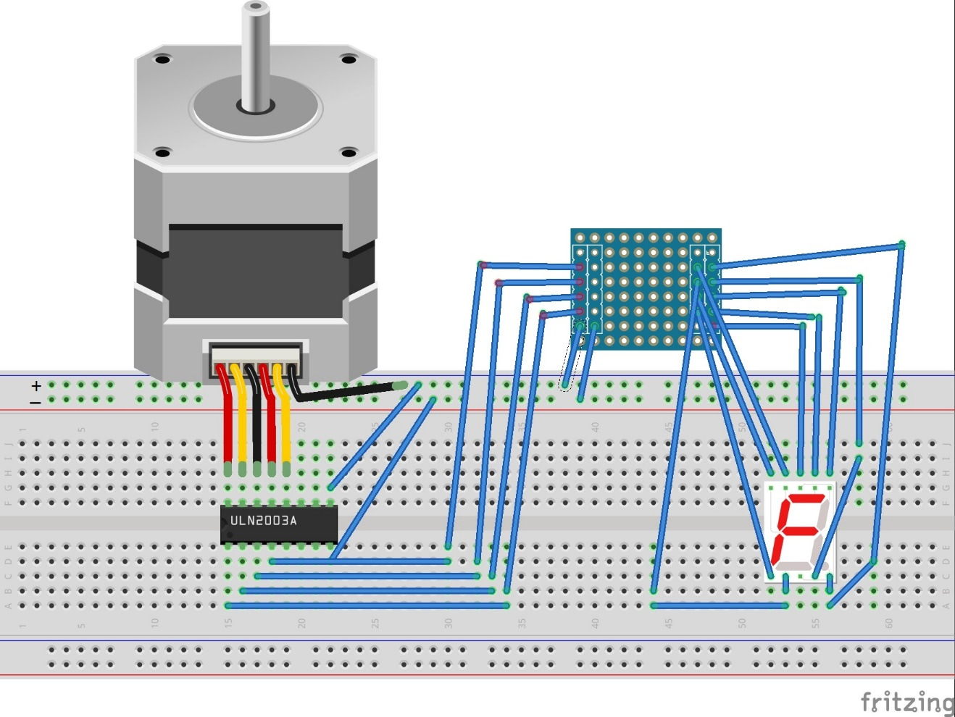

Another Block Diagram

As shown the final figure will be like that

***Procedure :***

-First as shown in the block diagram we connect the Driver of the stepper motor to the stepper motor so the driver output pins 1 , 2 , 3 , 4 connected to the blue, pink ,yellow, orange wires of the motor respectively then the last wire in the stepper is connected to the +ve terminal in the breadboard

-The 8th pin of unl on the right side is connected to the +ve of the breadboard and the 8th pin on the left hand side is connected to –ve of the breadboard

- The inputs of the unl (the first four pins in the left hand side is then connected to pins P 0.4 , P 0.5 , P0.6 ,P0.7 respectively then the VDD of P0 is connected to the +ve of the breadboard and the –ve of P0 is connected to –ve terminal of the breadboard

-Then we connect the 7-segment to P2 of the kit

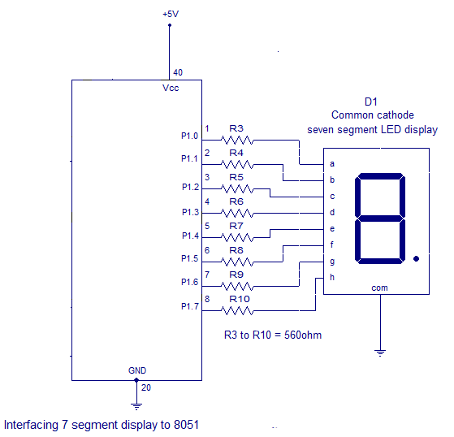So first we connect the –ve of P2 to com of the common cathode 7-segment

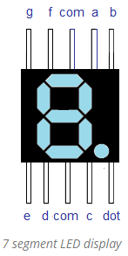

As shwn in the figure we connect the 7 –segment pins from a to h to Port from P2.0 to P.7

**Digit Drive Pattern:**

To display the digits on 7 segment, we need to glow different logic combinations of segments. For example if you want to display the digit 3 on seven segment then you need to glow the segments a, b, c, d and g. The below table show you the Hex decimal values what we need to send from PORT2 to Display the digits from 0 to 2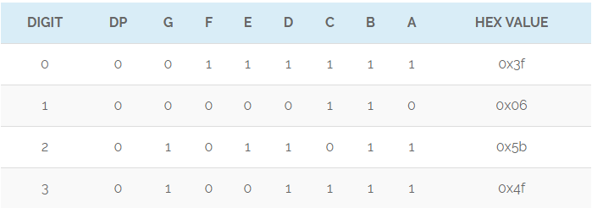

***Design :***

We build an elevator with 3 building 0 , 1 , 2 every floor has 1 push button and there is an extra button to present the opposition of any door in the 3 floors

- we also make an interrupt if anyone press a push button while the elevator is going up or down (in progress ) to store his order and apply it after performing the current order

- we make the clock of the kit 16 MHZ

-We also attach a video demonstration to how it works and the source code